ST BRUNO SS SSERUNKUUMAS GGOLI

PHYSICS EXAMINATION

LOWER CERTIFICATE OF SECONDARY EDUCATION

END OF CYCLE EXAMINATIONS 2023

S.3 PHYSICS
Time: 2hours and 15 minutes

STUDENTS NAME |  | STREAM
 |  | GROUP NAME

INSTRUCTIONS

[)? Attempt all questions in section A and any THREE from section B
[)? Any additional question(s) answered will not be marked

FOR EXAMINERS USE ONLY
Do not write in these boxes. The examiners will use them to keep a record of your marks
Questions |  | Marks
Section A
Section B | No
Section B | No
Section B | No
Total

SECTION A
- Two men went to buy a land and were made to tour two pieces of land A of dimensions 50m by 180m and land B of dimensions 1OOm by 1OOm. as a physics student with a valid explanation, advise the two men on which land to buy if the two pieces are of the same price.
…………………………………………………………………………………………………………………………………………………………………………………………………………………………………………………………………………………………………………………………………………………………………………………………………………………………………………………………………………………….................................................................................................(04nlks)
- (a) The Sun emits heat energy to the earth through space, state the mode of heat transfer from the Sun to the Earth.
………………………………………………………………………………………………………………………………………………………(Olmrk)
(b) explain why a person near the calm conditions at night feels a cool breeze from the land.
……………………………………………………………………………………………………………………………………………………………………………………………………………………………………………………………………………………………………………………………………………………………………………………………………………………………………………………………………………………………………………………………………………………………………………………………………………………….
(03tnrks)

- A student set up an experiment as shown below.

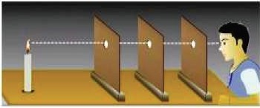
  - What principle was the student investigating?
…………………………………………………………………
.(01mrk)
  - Explain what is observed if one of the cardboard is slightly pushed off the line such that the holes are no longer in a straight line
……………………………………………………………………………………………………………………………………………………………………………………………………………………..
(02mrks

What conclusion can you make from 3(b) above.
…………………………………………………………………………………………………………………………
(Olmrk)
- An astronaut has a mass of 65Kg on earth, where the acceleration due to gravity is 10m/s2
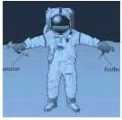

  - calculate the astronaut weight on earth.
……………………………………………………………………………………………………………………………………………………………………………………………………………………………………………………………………………………………………………………………………………………………….

(b) On moon the gravitational strength is
1.6 m./s2 Calculate the weight of 1he astronaut on themoon.
……………………………………………………………………………………………………………………………………………………………………………………………………………………………………………………………………………………………………………………………………………………………………………………………………………………………………………………………………………………………..

(()2 marks)
5.The Head teachers vehicle got a mechanicat break down and need to be lifted usinga hydraulic s.
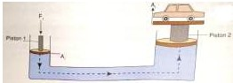

The piston of a hydraulic prct!s has their area given u 3.0xto·2m2 and 2xlo2m2 reepec1ively.Ifa student pushes down a smaller piston with a force of 120N. what is the force thatwill be exerted onthevehicle.
……………………………………………………………………………………………………………………………………………………………………………………………………………………………………………………………………………………………………………………………………………………………………………………………………………………………………………………………………………………………………………………………………………………………………………………………………………………………… 04 mark
6. a ) A barber was given a carved mirror of focal length 30cm so that he could use it shaving mirror in his saloon.
Identify the type of mirror given to the barber. (01 mark)
………………………………………………………………………………………………..

b) Use the ray diagram below to identify the type of mirror and state the 3 properties of the mirror

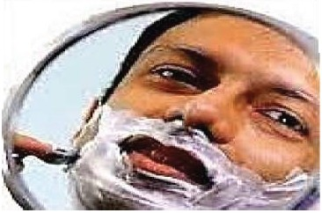

……………………………………………………………………………………………………………………………………………………………………………………………………………………………………………………………………………………………………………………………………………………………………………………………………………………………………………………………………………………………………………………………………………………………………………………………………………………………………………………………………………………………………………………………………………………………………………………………………………………………………………………………………………………………………………………………………………………………………03 marks

Thetlble below sllows tile velocity of a mewing car atdiffermt times

8

8
10
0
Draw a velocity- time graph ( use 1hesraph below and a convenient scale }

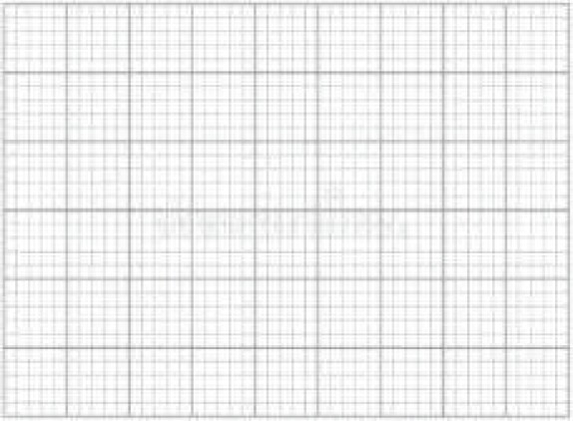

From 1he graph .calculate:
Average acceleratlon of the car In thefirst four seconds
…………………………………………………………………………………………………………………………………………………………………………………………………………………………………………………………………………………………………………………………………………………………………………………………………………………………………………………………………………………………………………………………………………………………………………………………………………………………………………………………………………………………………………………………………………………………………………………………………………………………………………………………………………………………………………………………03 mars

Acceleration of the car between the fourth and the eighth seconds.
………………………………………………………………………………………………………………………………………………………………………………………………………………………………………………………………………………………………………………………………………………………………………………………………………………………………………………………………………………………………………………………………………………………………………………………………………………………………………………………………………………………………………. 03 marks

Acceleration of the car du ri ng the last two seconds in motion
………………………………………………………………………………………………………………………………………………………………………………………………………………………………………………………………………………………………………………………………………………………………………………………………………………………………………………………………………………………………………………………………………………………………………………………………………………………………………………………………………………………………………………………………………………………………………………………………………………………………………………… 03 marks

Total distance covered by the ca r .
…………………………………………………………………………………………………………………………………………………………………………………………………………………………………………………………………………………………………………………………………………………………………………………………………………………………………………………………………………………………………………………………………………………………………………………………………………………………………………………………………………………………………… 03 marks

SECTION B:

6. Along :Kanvlini to :Kampala highway,a vehicle of mass l500Kg travelling at a velocity of 7.2Km/h towards Kampala collided with a stationary vehicle of mas 900Kg packed in kyrianilongo town.

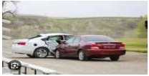
After collision, the two moved together at a constant velocity for 20 seconds. Calculate the;
  - common velocity after the impact (03mrb)
(b) distance moved after the impact (03mrb)
(c) loss in kinetic energy after collision. (04mrkB)

7. Challenges have arose in a certain village .Mixed beliefs ,anxiety, mistrust and poverty have cropped up . Rainbows happening to some places when it rains and illusionary water pools on sunny days on the road , have been attributed to the area clergy and witch doctors . Further more,there is change in colour where different objects are placed in the night security lghts of one resident ,who is believed to have miraculous powers of God . A lot of money is being spent by residents to get miracles or avoid misfortunes and evil spirits from the spiritual people .

TASK
As a physics learner ,prepare a speech you would give in the upcoming community meeting to address this challenge. 12scores

8.(a) On a certain sunny day, an uber driver saw a pool of water ahead on a tarmac road as he was driving. To his surprise, the pool disappeared as he approached it.Explain the uber diver’s surprise.

(b) On reaching Africana hotel, the passenger wanted to use the hotel’s swimming
pool which appeared to be about 1.5 m deep when its actual depth was 2.0 m.

Explain why the swimming pool appeared shallower than it actually is. Explain what would happen to the depth of the pool if water was replaced with paraffin.

(12 scores)

END

6

  - mechanic in one of the garage used the machine below to lift a lorry of 7500 N.

    - Identify the name of the machine (O1mark.)
- Determine the;
  - Mechanical advantage (03mrb) (iJ. Velocity ratio (03mrb)
(iii) Efficiency of the machine (03mrla)

9.a) In context to The sun- moon-- earth system , one wakes up at day break to catch the sun rising from the dark horizon .as it begins its daily journey from east to west across the sky. Finally the sinks out of view as night falls
.
- Is the sky moving or you are?
- What brings about day and night in your own view?

b) On a given day darkness came to our village in Mpigi district ,the sun got fully covered and the citizens were all worried thinking that the judgment day had come since none of them had any information about what was happening. As student of space physics help the villagers understand this phenomenon . 10marks

wishing you a merry x mass and a prosperous 2024
.

8

